Enterprise AI Data Analytics Portal
Knowledge Transfer & Handover Document
Prepared for incoming engineering owner(s)
Covers: architecture, module responsibilities, data flows, AI agent internals, and operational notes.

1. Application Overview
The Enterprise AI Data Analytics Portal is an Agentic Data Analyst: a full-stack, cloud-integrated platform that lets non-technical business users — executives, sales managers, marketers — query relational data using plain English instead of SQL, BI tools, or IT tickets.
It is powered by the Google Gemini Pro LLM and backed by a hardened PostgreSQL cloud database (Supabase). The system translates business questions into safe, optimized SQL, executes them, and returns human-readable insights and interactive charts in real time.

1.1 Problem It Solves
- The data bottleneck — business leaders need fast answers, but data teams are overwhelmed with ad-hoc reporting requests.
- Siloed knowledge — quantitative data (sales numbers) is rarely connected to qualitative rules (discount policies, handbooks).
- Trust and hallucinations — most AI tools invent numbers. This system uses a deterministic validation engine to guarantee zero-hallucination quantitative reporting by executing verified, read-only SQL rather than letting the LLM state figures directly.

1.2 Core Features
- Conversational AI Assistant — natural-language chat that streams a live “Thought Trace,” auto-joins tables via the Star Schema, and renders Plotly.js charts inline.
- Analytical Data Explorer — a data grid for browsing raw tables, plus a one-click AI Data Quality Scan that returns a structured JSON list of anomalies.
- Executive Reporting & Dashboarding — on-the-fly aggregated charts with LLM-written 3-sentence insights, plus an automated daily HTML report emailed via SMTP.
- AI Policy Hub (RAG) — uploaded .txt policy documents (handbooks, discount rules) are retrieved via pgvector similarity search and blended with structured sales data to answer policy questions.

1.3 User Personas
Persona | Primary Usage
Executive / C-Suite / VP | Automated daily email reports and quick chat-based KPI checks.
Sales / Marketing Manager | Dashboard for trend spotting; chat for drilling into regional anomalies.
Data Engineer / Admin | Data Explorer for AI Quality Scans; monitors generated SQL and schema health.

2. System Architecture
The application is split into three layers: a React frontend, a FastAPI backend/orchestration layer, and an AI orchestration + data layer built on LangChain, Gemini, and Supabase (Postgres + pgvector).
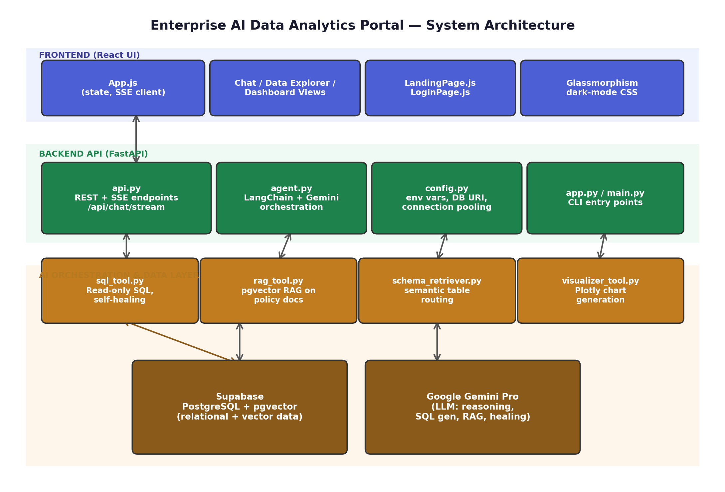
Figure 1 — High-level system architecture across the three layers.

2.1 Layer Responsibilities
- Frontend (React) — manages state, renders data grids and Plotly charts, and consumes Server-Sent Events (SSE) for real-time AI “typing” / thought traces.
- Backend API (FastAPI) — orchestration layer exposing REST endpoints and SSE streams, handling DB connection pooling, and parsing AI responses before they reach the frontend.
- AI Orchestration & Data Layer (LangChain + Supabase) — LangChain coordinates Gemini Pro, which is equipped with specialized tools for SQL, RAG, and chart generation; all data lives in Supabase (Postgres + pgvector).

3. Module & File Responsibilities
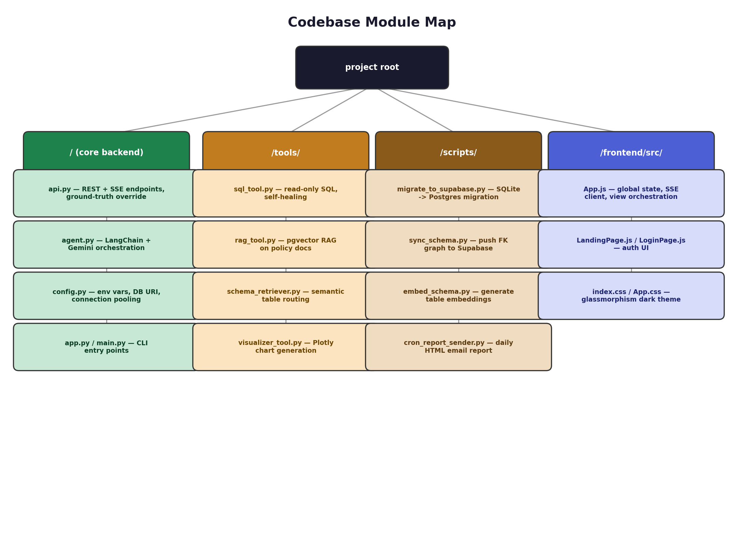
Figure 2 — Codebase module map.

3.1 Core Backend & API Layer (root directory)
- api.py — the main FastAPI server and primary Frontend–Backend interface. Defines all REST endpoints (/api/databases, /api/tables, /api/dashboard/*, /api/report/*) and the critical SSE endpoint /api/chat/stream. Implements a lifespan event that auto-syncs schema relationships to Supabase on startup, and “Ground-Truth Override” logic that intercepts LLM hallucinations and replaces them with actual SQL results.
- app.py / main.py — entry points for running the backend or an interactive terminal CLI version of the AI agent without the React frontend.
- agent.py — the AI orchestration engine. Initializes the LangChain agent with Gemini Pro, binds the SQL/RAG/Visualizer tools to the LLM, and manages conversational memory.
- config.py — centralized configuration: environment variables, database URI construction, and SQLAlchemy connection-pooling settings.

3.2 AI Tools Module (/tools/)
- sql_tool.py — bridges the AI and the relational database; executes AI-generated SQL securely (read-only validated) and caches the exact result set in last_query_dataframe. See Section 4.1 for the full flow.
- rag_tool.py — semantic search engine over unstructured policy documents using pgvector. See Section 4.2.
- schema_retriever.py — the “mental map” builder — in-memory Foreign Key graph traversal so the AI knows how to JOIN tables correctly. See Section 4.3.
- visualizer_tool.py — takes pandas DataFrames and generates Plotly JSON objects or static image files per the AI's instructions.

3.3 Initialization & Automation Scripts (/scripts/)
Used for setup, migration, and background tasks; not called by the frontend during normal operation.
- migrate_to_supabase.py — migrates local SQLite data to the cloud PostgreSQL instance.
- sync_schema.py — reads data/schema_metadata.json and pushes FK relationships to the schema_relationships table so all backend instances share the same schema graph.
- embed_schema.py — generates vector embeddings for table descriptions and stores them via pgvector.
- cron_report_sender.py — background script that uses the AI to generate a daily HTML executive summary and emails it via SMTP.

3.4 Frontend Module (/frontend/src/)
- App.js — the monolithic main application component. Manages global state (current database, chat history, active view), handles the SSE connection to /api/chat/stream, and orchestrates transitions between Chat, Data Explorer, and Dashboard views.
- LandingPage.js / LoginPage.js — initial entry and authentication UI components.
- index.css / App.css — vanilla CSS defining the “Glassmorphism” dark-mode aesthetic.

4. AI Agents & Tools — Deep Dive
These three tools are the specialized capabilities bound to the Gemini LLM. When the agent decides it needs to act, it invokes one of these.

4.1 SQL Agent (tools/sql_tool.py)
Not a simple passthrough — a defensive, self-correcting, read-only SQL execution engine designed to prevent data corruption and eliminate hallucinations.
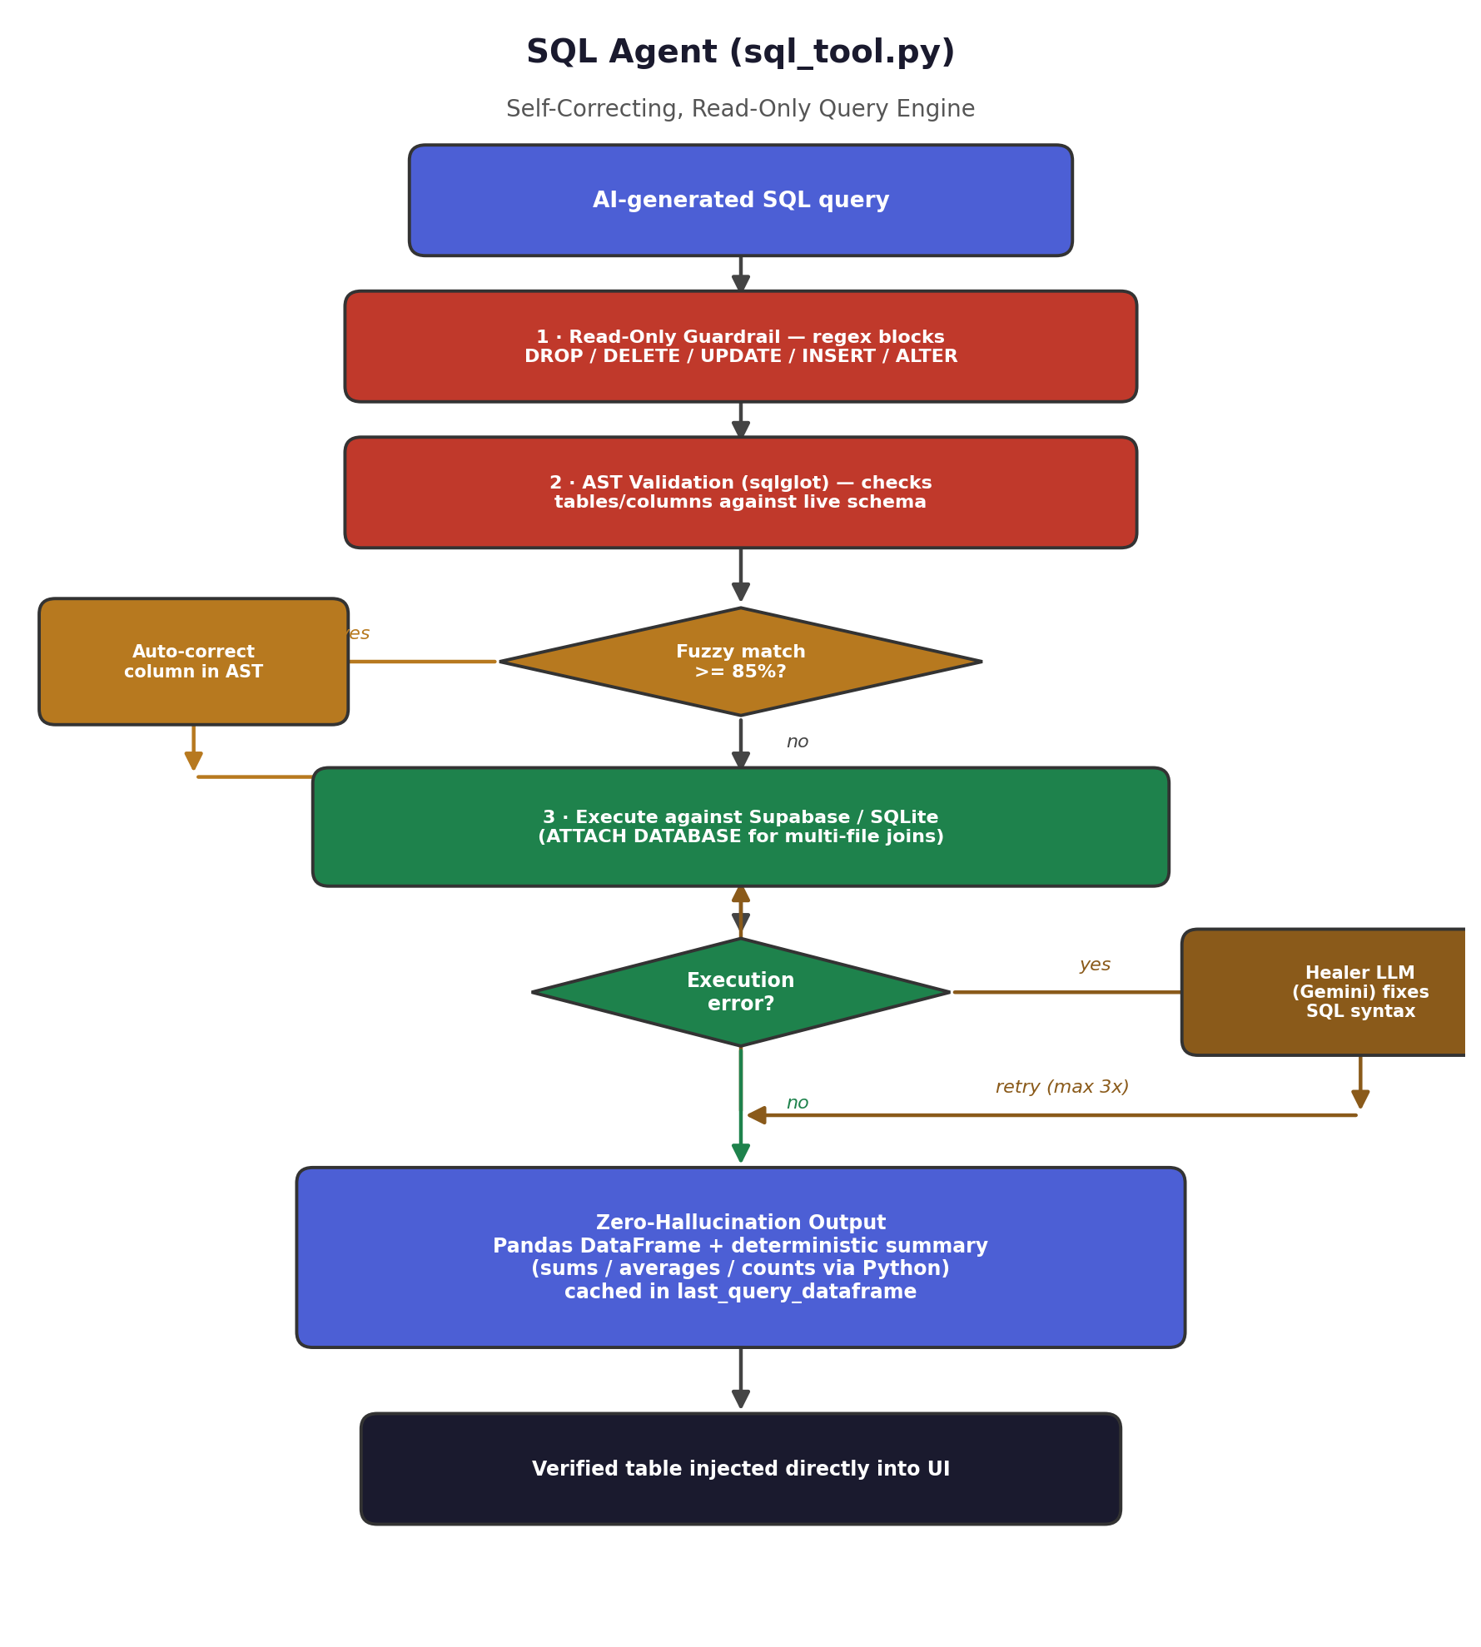
Figure 3 — SQL agent self-correcting execution flow.

Flow steps
- Read-Only Guardrail: strict regex inspects the first token; blocks all DML/DDL (DROP, DELETE, UPDATE, INSERT, ALTER, etc.) — only SELECT proceeds.
- Deterministic AST Validation: the query is parsed via sqlglot; every table/column reference is cross-checked against the live schema through SQLAlchemy.
- Auto-Correction: hallucinated column names (e.g. quantity vs qty) are fixed using hardcoded synonyms plus difflib fuzzy matching at an 85% threshold.
- Execution & Self-Healing: validated SQL runs against Supabase (or SQLite locally, using ATTACH DATABASE for multi-file joins). On failure, the error/schema/failed SQL go to a dedicated “Healer” Gemini call, retried up to MAX_RETRIES = 3.
- Zero-Hallucination Output: raw rows become a Pandas DataFrame; a deterministic Python/Pandas summary (sums, averages, unique counts) is generated — not the LLM — and cached in last_query_dataframe so the API can inject the verified table directly, bypassing the LLM.

4.2 RAG Agent (tools/rag_tool.py)
Connects the AI to unstructured corporate knowledge — .txt policy manuals and product guidelines in the docs/ folder.
- Ingestion & Chunking: LangChain's TextLoader loads files; RecursiveCharacterTextSplitter splits into overlapping chunks (size 500, overlap 50).
- Embedding: chunks are embedded with Google's gemini-embedding-001, truncated to 1536 dimensions via Matryoshka Representation Learning (MRL).
- Storage: cloud mode pushes embeddings to a pgvector store on the same Supabase instance as the relational data (no separate vector DB); local mode falls back to an in-memory NumPy cosine-similarity store.
- Retrieval: the user query is embedded, top k = 4 relevant chunks are retrieved, and formatted with source filenames before being fed to the LLM.

4.3 Schema Retriever (tools/schema_retriever.py)
Acts as a Semantic Table Router: with hundreds of tables in a typical enterprise DB, feeding the full schema into every prompt wastes tokens and confuses the model, so this component identifies exactly which tables a given query needs.
- Semantic Search: embeds the user query with gemini-embedding-001 and searches the table_embeddings table in Supabase (system tables like langchain_pg_collection are excluded).
- Dynamic Relative Pruning: keeps all tables within a 0.16 similarity delta of the top match — more robust than a fixed absolute threshold. If the top score is below 0.15 (pure noise), only the single top table is returned.
- 1-Hop Star Schema Expansion: using the FK graph in schema_relationships, adjacent tables are pulled in only if their own base semantic score is ≥ 0.20, preventing irrelevant bridge tables from leaking in.
- Hard Capping: the final table list is capped at MAX_TABLES = 8; SQLAlchemy's inspect() then builds a lightweight “Core Schema” block (CREATE TABLE definitions, PKs, FKs) for those tables, injected into the system prompt.

5. Key Frontend–Backend Data Flows
Four interactions matter most when working on the UI or API layer.
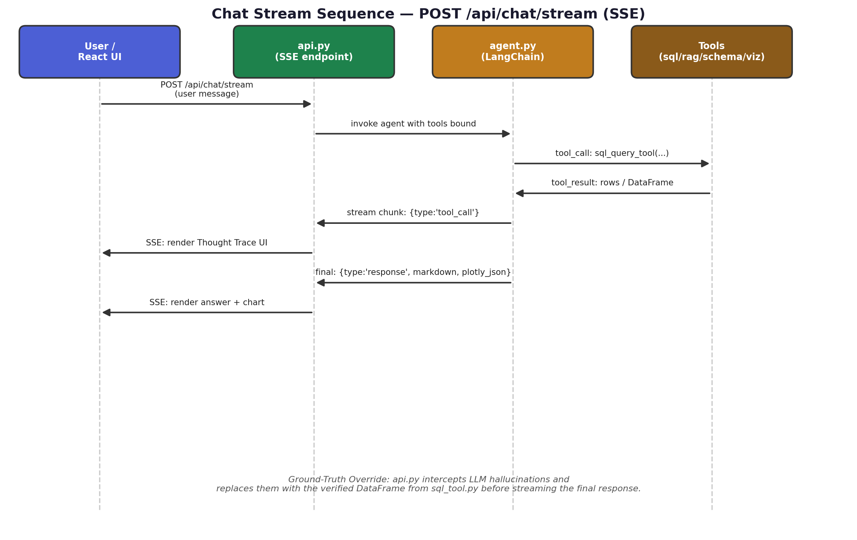
Figure 4 — Chat stream (SSE) sequence.

5.1 The Chat Stream — POST /api/chat/stream
- Trigger: user submits a chat message.
- Transport: Server-Sent Events (SSE); the UI listens for streamed chunks.
- Payload types: {type: "tool_call"} → render a Thought Trace indicator (e.g. “AI is querying the database…”); {type: "tool_result"} → raw tool output; {type: "response", content, plotly_json, tokens} → final Markdown answer, rendered with react-plotly.js if plotly_json is present.

5.2 AI Data Quality Scan — POST /api/tables/{table_name}/ai-scan
- Trigger: user clicks “Run AI Audit” on a table in the Data Explorer.
- Backend action: pulls a sample of rows, sends them to Gemini, and requests anomaly detection.
- Response shape: [{title, severity, description, recommendation, affected}] — render as warning cards or an audit panel.

5.3 Chat Suggestions — GET /api/chat/suggestions?context=
- Trigger: page load, or after an AI response completes.
- Response: {suggestions: […]} — render as clickable chips above the chat input.

5.4 Dashboard Generation — POST /api/dashboard/ai-insight & /api/dashboard/chart
- Trigger: user opens the Executive Dashboard.
- Flow: UI requests aggregated charts; for each chart's underlying data it can optionally request a 3-sentence AI business insight.
- UI requirement: a grid of Plotly charts with insight text cards beneath each one.

6. Architectural Notes for the Incoming Owner
- State management — the frontend relies on React's useState and prop drilling — no Redux. Keep state simple unless scaling genuinely requires the Context API.
- Resilience — the backend may restart or drop connections; the UI implements a safeFetch wrapper to handle network errors gracefully without crashing the React tree.
- Aesthetic direction — enterprise audience, premium feel — deep dark themes, subtle gradients, glassmorphism (translucent blurred panels), and micro-animations such as pulsing dots during tool execution. Should read as a modern intelligent workspace (think ChatGPT Enterprise / modern BI tools), not a raw DB admin tool like pgAdmin.
- Transparency by design — the Thought Trace (tool_call / tool_result streaming) is a core UX pillar — don't hide or collapse it away; it's what builds user trust in the AI's answers.
- Zero-hallucination guarantee — any refactor of api.py or sql_tool.py must preserve the Ground-Truth Override — numeric answers must always come from the cached DataFrame, never from raw LLM text.

7. Suggested Areas to Review First
- Read api.py end-to-end to understand endpoint surface and the SSE streaming contract.
- Trace one full chat request through agent.py → schema_retriever.py → sql_tool.py to see the tool-binding pattern.
- Review the MAX_RETRIES / self-healing loop in sql_tool.py — a common source of latency or cost spikes if the AI repeatedly fails to write valid SQL.
- Check scripts/sync_schema.py and embed_schema.py — these must be re-run whenever the underlying database schema changes, or the AI's table routing and JOINs will silently go stale.
- Confirm SMTP credentials and schedule for cron_report_sender.py if daily executive emails are in scope for continued operation.

